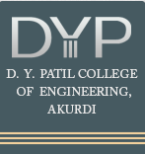
D. Y. Patil College of Engineering, Akurdi, Pune-44.
Department of Computer Engineering

Review 1

Group no – 20

Sr.No | Name | Roll No | Sign
1 | Omkar Ghodekar | BECO2526B067
2 | Utkarsh Salunke | BECO2526B048
3 | Raj Wagh | BECO2526B008
4 | Sandhya Dhaygude | BECO2526B046

B.E. Computer Engineering SEM-I

Title : SkillBridge: AI-Powered Career Development and Job Readiness Platform

- TECHNICAL KEYWORDS :
- AI-Powered Platform
- Job Readiness
- Skill Matching Resume
- Analysis Mock Interview
- NLP
- Machine Learning
- Career Recommendation
- User Profiling
- Keyword Extraction and Weighting
- Machine Learning Algorithms
- Semantic Similarity Scoring
- Skill Gap Detection
- Interview Simulation
- Applicant Tracking System (ATS) Optimization

Problem Statement and Motivation:
In today’s fast-paced world, simply obtaining a degree is not enough to secure the right job. Students and young professionals often struggle with identifying roles that suit their skills, understanding what skills they lack, and confidently preparing for interviews. These challenges can lead to underemployment and missed opportunities—not due to a lack of talent, but rather a lack of direction and structure.
Motivation:
SkillBridge is designed to bridge the gap between education and employment. It equips users with personalized job matching, skill gap analysis, resume optimization, and AI-driven mock interviews—all in one platform. This approach empowers fresh graduates, career changers, and colleges to improve job readiness in a targeted, structured way.

- REVIEW OF LITERATURE:

Sr.No | Title and Author | Conference / Journal Name & Publication Year | Topic Reviewed/ Algorithms or Methodology used | Advantages and Disadvantages
1 | SkillForge AI-Powered Learning & Placement Platform - Krishnan, S. et al. | 2025 11th ICCSP, IEEE | AI-powered platform for learning and placement using personalized learning pathways and skill tracking. | Advantages: Personalized learning, integrated placement support.  Disadvantages: High implementation complexity, dependent on accurate profiling.
2 | AI knows you: Prediction of extroversion trait - Naz, A. et al. | IEEE Access, 2024 | Deep learning model (CNN) for personality trait prediction using social media/textual data. | Advantages: Predicts personality traits effectively.  Disadvantages: Privacy concerns, needs large labeled data.
3 | Contribution of Job Readiness Application - Nurmalasari, R. | 2021 7th ICEEIE, IEEE | Survey-based analysis using regression on job readiness factors and competency mapping. | Advantages: Provides empirical insight into education-employment gap.  Disadvantages: Limited to certain demographics or regions.
4 | Prediction of Student Job Readiness - Gemilang, H. et al. | 2024 ICoDSA, IEEE | MLP and XGBoost to predict job readiness from student performance metrics. | Advantages: High prediction accuracy with ensemble models.  Disadvantages: Data quality sensitive, model interpretability low.
5 | Enhancing Career Readiness - Jiranantanagorn, P. | 2023 CSDE, IEEE | Online platform for competency assessment and matching with workplace preferences. | Advantages: Facilitates self-assessment and employer matching.  Disadvantages: Requires regular platform updates and employer participation.
6 | Collaborative Mock Interview Platform - Ahmad, M.M. et al. | 2024 OTCON, IEEE | Web-based mock interview with collaborative tools, AI feedback. | Advantages: Real-time collaboration, useful for preparation.  Disadvantages: Quality dependent on AI feedback system.
7 | Virtual Job Interview Simulator - Rao, G.S. et al. | 2025 ICOEI, IEEE | NLP-based virtual interviewer using real-time text and audio processing. | Advantages: Simulates real interviews, improves confidence.  Disadvantages: NLP limitations may affect accuracy.
8 | Intelligent Resume Recommendation - Mishra, A. et al. | 2024 ICCCNT, IEEE | NLP-based resume parser and recommender with feedback system. | Advantages: Provides personalized resume improvements.  Disadvantages: May overlook creative/unique formats.
9 | AI-Powered Mock Interview Platform - Sharma, T. et al. | 2025 ICSSAS, IEEE | Combines Computer Vision, NLP, and GenAI to simulate interviews and evaluate responses. | Advantages: Multi-modal analysis of interview performance.  Disadvantages: High resource consumption.
10 | AI-Powered Resume Builder - Jha, R. et al. | 2025 ICDT, IEEE | AI-based resume template recommender and content enhancer. | Advantages: Boosts application quality with intelligent suggestions.  Disadvantages: May generate generic suggestions.

System Design and Architecture:

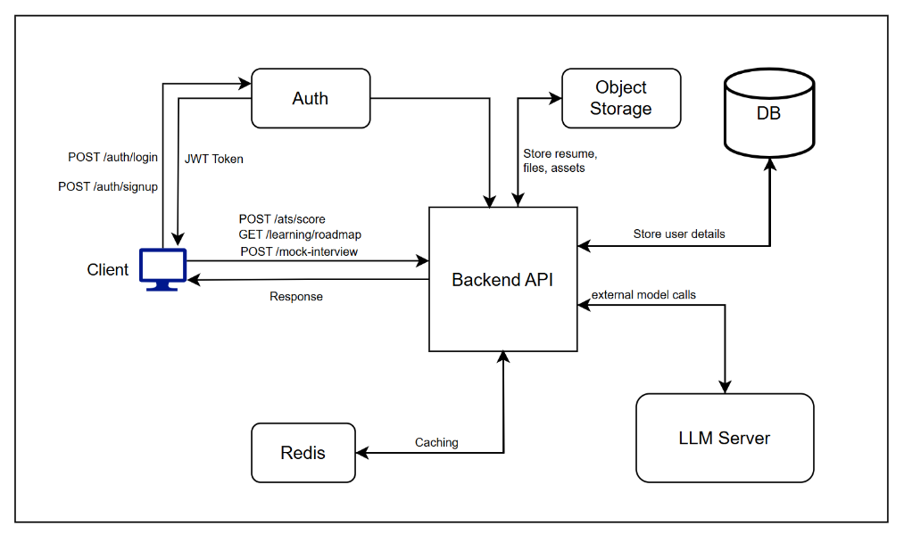

System Design

SkillBridge is architected as a modern, modular web platform that leverages the following major components:

- Client: User-facing web/mobile UI, supporting login, profile management, resume upload, interview practice, and dashboard features.
- Auth: Secure authentication (JWT-based), handles user registration and login.
- Backend API: Central business logic; mediates all requests and data flow.
- Object Storage: For scalable storage of user-uploaded files (resumes, certificates, etc).
- Database (DB): Persistent storage for user profiles, skills, job listings, activity data.
- Redis: Caching layer for rapid access to common data and scalable performance.
- LLM Server: Provides NLP and AI functionalities (skill extraction, resume scoring, mock interview simulation, etc).

Key Interactions:
- The Client interacts with the Backend API for all main operations.
- Authentication is managed via the Auth service, which issues JWT tokens for secure requests.
- Backend API stores/retrieves assets via Object Storage and persists structured data in the Database.
- Redis caches frequently accessed data to optimize speed.
- LLM Server is invoked for advanced AI functionalities (semantic similarity, skill matching, feedback, etc).

Task | Start Date | End Date | Status
Research & Synopsys | 01/07/25 | 10/07/25 | Complete
Literature Review | 01/07/25 | 18/07/25 | Complete
Architecture/Design | 15/07/25 | 26/07/25 | Complete
Backend Setup | 27/08/25 | 10/09/25 | Next up
Auth & Profile Engine | 27/08/25 | 08/09/25 | Next up
Resume/Skill Analyzer | 10/09/25 | 18/09/25 | Upcoming
LLM Integration | 10/09/25 | 20/09/25 | Upcoming
Prototype User Dashboard | 21/09/25 | 28/09/25 | Upcoming
Final Testing & Review | 29/09/25 | 06/10/25 | Upcoming

Feasibility Study:
- Technical Feasibility: Utilizes widely adopted technologies (REST APIs, JWT auth, cloud object storage, modern ML/NLP frameworks, scalable DBs). Approach is well within the existing technical competence of the team.
- Operational Feasibility: Directly targets both students and placement coordinators, increasing job readiness and placement efficiency.
- Economic Feasibility: Open-source software, scalable cloud infrastructure, and modular design lower recurring costs and ease future updates.

6. Project Planner

- REFERENCE
- Krishnan, S., Madhumitha, L., Manikandan, V. and Karthick, A.G., 2025, June. SkillForge AI-Powered Learning & Placement Platform. In 2025 11th International Conference on Communication and Signal Processing (ICCSP) (pp. 837-842). IEEE.
- Naz, A., Khan, H.U., Alesawi, S., Abouola, O.I., Daud, A. and Ramzan, M., 2024. AI knows you: deep learning model for prediction of extroversion personality trait. IEEE Access.
- Nurmalasari, R., 2021, October. Contribution of Job Readiness Application and Student Competency Towards Job Readiness and Job Opportunities in Industry. In 2021 7th International Conference on Electrical, Electronics and Information Engineering (ICEEIE) (pp. 1-4). IEEE.
- Gemilang, H. and Lhaksmana, K.M., 2024, July. Prediction of Student Job Readiness Using MLP and XGBoost Method. In 2024 International Conference on Data Science and Its Applications (ICoDSA) (pp. 248-253). IEEE.
- Jiranantanagorn, P., 2023, December. Enhancing Career Readiness: An Online Platform for Competency Assessment and Workplace Selection in Cooperative and Work-Integrated Education for Thai University Students. In 2023 IEEE Asia-Pacific Conference on Computer Science and Data Engineering (CSDE) (pp. 1-6). IEEE.
- Ahmad, M.M., Srivastava, P., Bharti, V., Shamsi, M.F., Jain, A. and Vishnoi, A., 2024, June. Collaborative Mock Interview Platform. In 2024 OPJU International Technology Conference (OTCON) on Smart Computing for Innovation and Advancement in Industry 4.0 (pp. 1-5). IEEE.
- Rao, G.S., Jaiganesh, M. and Parida, P.K., 2025, April. AI Powered Virtual Job Interview Simulator Using Natural Language Processing. In 2025 8th International Conference on Trends in Electronics and Informatics (ICOEI) (pp. 1413-1421). IEEE.
- Mishra, A., Singh, S. and Jisha, R.C., 2024, June. AI-Powered Model for Intelligent Resume Recommendation and Feedback. In 2024 15th International Conference on Computing Communication and Networking Technologies (ICCCNT) (pp. 1-6). IEEE.
- Sharma, T., Singh, A., Singh, S. and Gupta, G., 2025, June. AI-Powered Mock Interview Platform using Computer Vision, Natural Language Processing and Generative AI. In 2025 3rd International Conference on Self Sustainable Artificial Intelligence Systems (ICSSAS) (pp. 1258-1263). IEEE.
- Jha, R., Paliwal, G. and Jha, B.K., 2025, March. AI-Powered Resume Builder: Enhancing Job Applications with Artificial Intelligence. In 2025 3rd International Conference on Disruptive Technologies (ICDT) (pp. 1655-1660). IEEE.

Dr. M. A. Potey Dr. Shanthi . K Guru
(Project Guide) (Project Coordinator)

Dr. M. A. Potey
(HOD Comp Engg)

